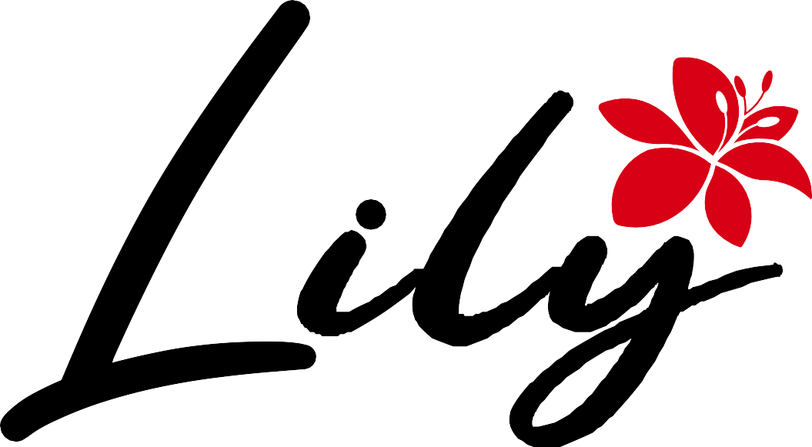
Coffee, tea & bread

Private Event Agreement
This Private Event Agreement (“Agreement”) is entered into between Lily Coffee, Tea & Bread (“Venue”) and the undersigned Client.

1. Event Details
Client Name: ______________________________
Phone / Email: ____________________________
Event Type: _______________________________
Event Date: _______________________________
Event Start Time: _________________________
Event End Time: ___________________________
Estimated Guest Count: ____________________

2. Event Timing & Access
• Private events are held after store hours unless otherwise approved by the Venue.
• Rental options are 2–4 hour time blocks.
• Clients may access the space 30 minutes before the event for setup.
• All guests and personal items must exit the premises by the scheduled end time.
• Late departures may result in additional staffing fees.

3. Rental Fees & Minimum Spend

Rental Fees (if minimum spending is not met):
Monday – Thursday
- 2 hours: $150
- 3 hours: $200
- 4 hours: $250
Friday – Sunday
- 2 hours: $200
- 3 hours: $280
- 4 hours: $350
Minimum Food & Beverage Spend (Rental Fee Waived):
- Monday – Thursday: $300
- Friday – Sunday: $400
Minimum spend applies to food and beverage purchased from Lily Coffee, Tea & Bread only.

4. Payment Terms
• A 50% non-refundable deposit is required to secure the event date.
• The remaining balance is due 7 days before the event.
• Final guest count must be confirmed 5 days prior to the event and cannot be reduced after this date.

5. Cancellation & Rescheduling
• Cancellations more than 7 days before the event: deposit is retained.
• Cancellations within 7 days of the event: full minimum spend is due.
• One reschedule is permitted, subject to availability.

6. Catering & Outside Food
• Outside food and beverages are not permitted without prior approval.
• Outside cakes or desserts may be approved case-by-case.
• Alcohol is not permitted unless approved by the Venue.

7. Clean-Up & Item Removal
Client is responsible for:
• Removing decorations, gifts, and personal items
• Clearing tables of personal décor and supplies
• Ensuring no items are left behind
The Venue will handle standard cleaning related to in-house food and beverage service.
Excessive mess or damage may result in a cleaning fee of $50–$150.
Items left behind will be held for 48 hours before disposal.

8. Decorations & Space Use
• Decorations are welcome but must be removable and damage-free.
• No nails, tacks, tape on walls, confetti, glitter, smoke machines, or poppers.
• Candles are permitted on cakes only.
• Kitchen areas, equipment, and staff spaces are off-limits.

9. Conduct & Liability
• Client is responsible for the behavior of all guests.
• Children must be supervised at all times.
• Lily Coffee, Tea & Bread is not responsible for lost or stolen items.
• Client agrees to cover any damage caused during the event.

10. Event Policy
The Venue does not host:
• Ticketed or public events
• Loud parties or DJ-style events
• Events requiring outside vendors without approval
• Events that may disrupt neighboring businesses
The Venue reserves the right to decline or end events that violate this Agreement.

11. Force Majeure
The Venue shall not be responsible for cancellations caused by circumstances beyond its control, including natural disasters, power outages, or government restrictions.

12. Agreement Acknowledgment
By signing below, the Client acknowledges that they have read, understood, and agree to the terms of this Agreement.
Client Signature: __________________________
Printed Name: ______________________________
Date: _____________________________________
Venue Representative: ______________________
Date: _____________________________________

